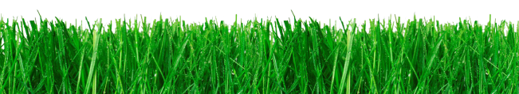
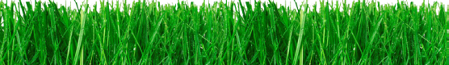
10TH ANNUAL
GOLF TOURNAMENT
TUESD AY, M AY 10, 2016

BEAR’S BEST ATLANTA 5342 Aldeburgh Drive, Suwanee, GA 30024

Auction Donation Form
ISDD is a 501(c)(3)organization. Tax ID: 20-1060068

Donor or Company Name
Contact Person
Mailing Address
City, State, Zip Code
Phone
Email

Item Description

Restriction or Limitations
(Please be specific)

Retail Value | $

Please put an X next to one of these options:

Item is enclosed
I will deliver item by May 10, 2016
The item needs to be picked up
Please make a gift certificate for this item

For more information contact: Rainie Jueschke, CFRE, Executive Director, rainiej@isdd-home.org or 404-600-3332
750 Hammond Drive Building 1, Suite 100 Atlanta, GA 30328 • (404) 600-3332 • www. isdd-home.org

Email this form to: rainej@isdd-home.org

